**ECE 5425**  **Project1 Report**

**Group #8. Li Lin & Zhaofeng Tian**

1. **Abstract**

In this study, a three-links robot is built with hardware components and Matlab model. DH parameters are improved by optimization.

1. **Introduction**

As automation is growing fast all over the world, robotics is one of the most promising industries that would contribute significantly to human society. In the auto industry, the robot arm is commonly used to grab and move mechanical parts, while also help weld parts in the workspace; As a product of mechanical engineering, electrical engineering, and computer science, the robot arm can be commanded to do high accuracy motions which outperform human beings. Thus, the robot arm is used in the medical industry as well, to perform operations for the patients; In terms of STEM education, a three-link robot arm could interest kids very much, and inspire them to chase STEM dream in the future.

In this study, we propose a three-link robot arm called “G8 robot arm”, and showcase how we build it in physical world, create simulation environment in Matlab App designer, and how we optimize DH parameters using the comparisons between measurements of the distance from end-effector to clipboard frame origin and corresponding calculation results from simulation.

Rest report sections are arranged as follows. In section III, our methods of building robot in physical world and the simulation environment are proposed; In section IV, our results of DH parameter optimization are shown; Conclusion and Discussion are respectively put in sections V and VI.

1. **Methods**

In this section, the details of building process are illustrated step by step, which synchronizes with the project-required steps.

In the first step, we arrange the base on the clipboard such that we have the maximum joint ranges and that the robot can reach all corners of the given board with this additional criterion, we shorten one of the joint lengths of robot arm by the smallest digit from all group members student id. So, as the smallest digit in my group ids is “1”, we shorten link 1 and 2 by 1 hole from the max length shown as the Fig. 1.

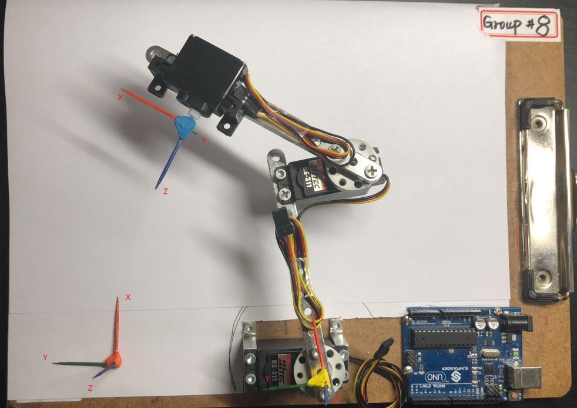

Clipboard coordinate system

Fig. 1 Robot arm setup

As you can see, we move the base frame along the Y axis for 0.08 meters to get a clipboard frame, where the one of two toothpick-made frames locates. The other toothpick-made frame locates at the end-effector frame origin. Then all the measurements are pointed from end-effector to the clipboard frame instead of the base frame, which should be noted and is set as default in latter measurements.

In the second step, we tried several possible angles to locate the end-effector, and finally choose the current setup shown as Fig. 2(a). Meanwhile, we have drawn the range limits of the end-effector on a piece of paper.

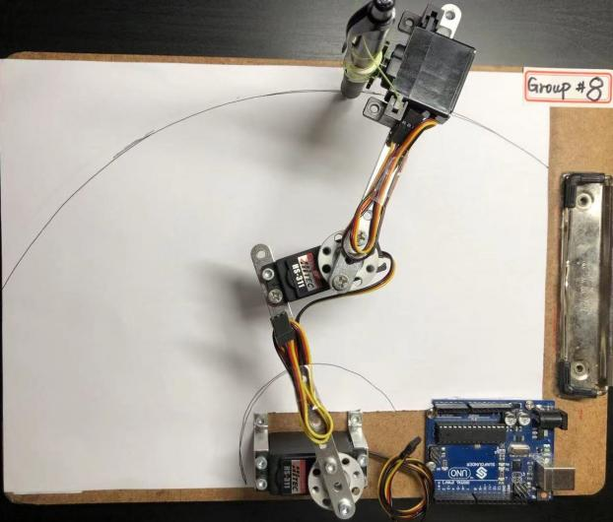 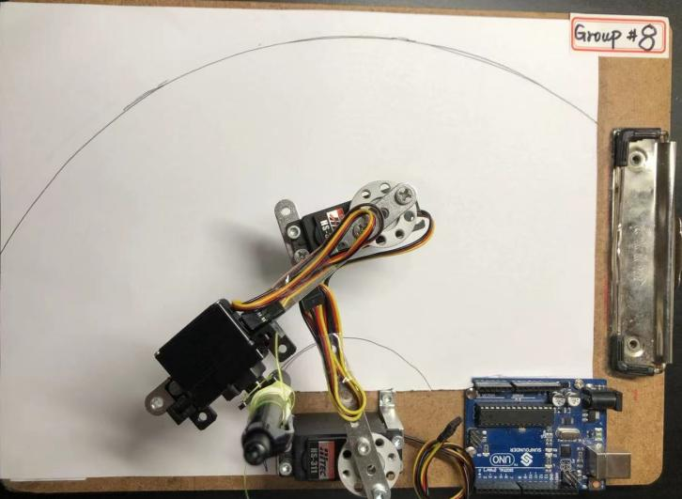

(a)

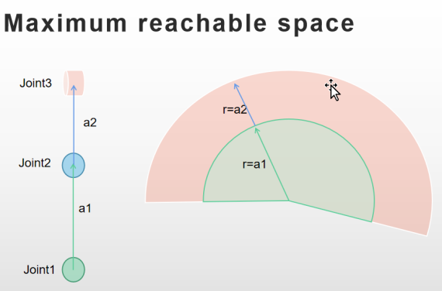 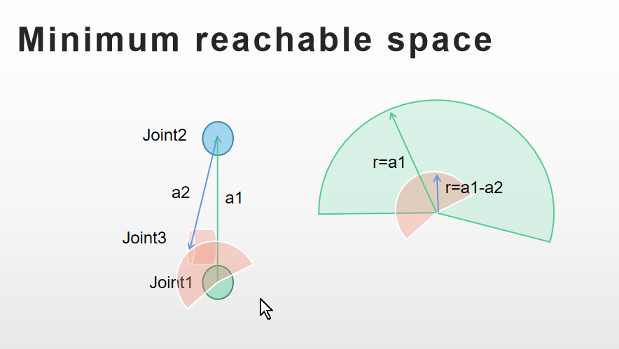

(b)

Fig. 2 Minimum and Maximum range of the end-effector.

FromFig.2 (b), we can get the reachable space of the end-effector as the red area shows.

In the step 3, we put the toothpick-made frames at the respective locations shown as Fig.1.

In the step 4, we measure the DH parameters for the robot arm following the textbook instructions. All measured DH parameters including theta value limit (joint angle limit) and offsets are shown in the Table. 1 below.

|  |  |  |  |  |  |
| --- | --- | --- | --- | --- | --- |
|  | a  (m) | alpha (degree) | d  (m) | theta  (degree) | offset  (degree) |
| Joint 1 | 0.1 | 0 | 0 | -90 ~ 120 | -19 |
| Joint 2 | 0.073 | -90 | 0.02 | -120 ~ 90 | 16.8 |
| Joint 3 | 0.0 | 0 | 0.02 | 0 ~ 135 | 0 |

Table 1. DH parameters.

1. Firstly, we create a GUI in the Matlab App designer shown as Fig. 3 to tune the DH parameters and showcase the result by plotting the robot based on preset DH parameters. Note that Base Frame Translation section in the GUI, we set the clipboard coordinate system showing as Fig.1 which origin is [0 0 0]. So the base frame of robot arm translated with vector[0 -0.08 0.47] refer to clipboard frame. And we define the base frame and joint1 frame at the same place.

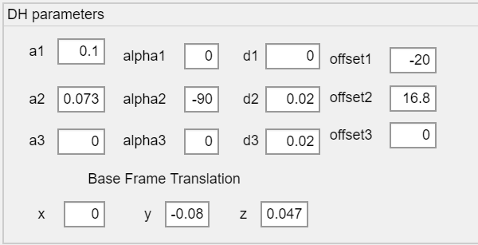

Fig. 3 DH parameters GUI

1. Secondly, to explain how the DH parameters are determined, here we are using a image to illustrate it. In the Fig. 4, all DH parameters are labeled on the links and joints. In the Fig.5, offsets are labeled.

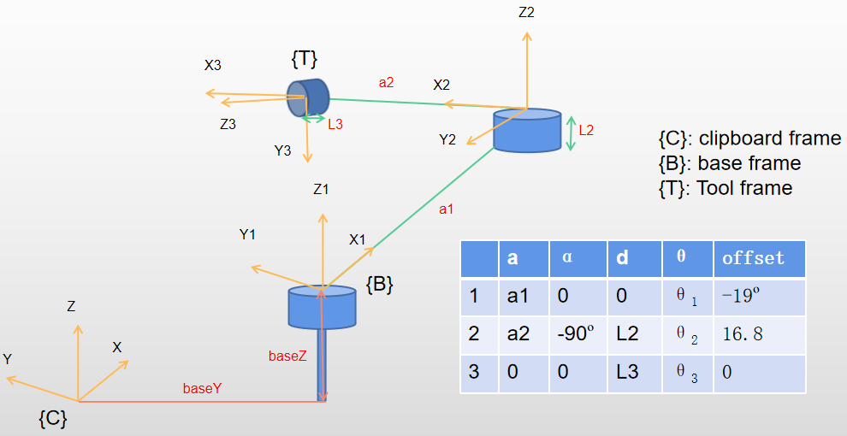

Fig. 4 DH parameters

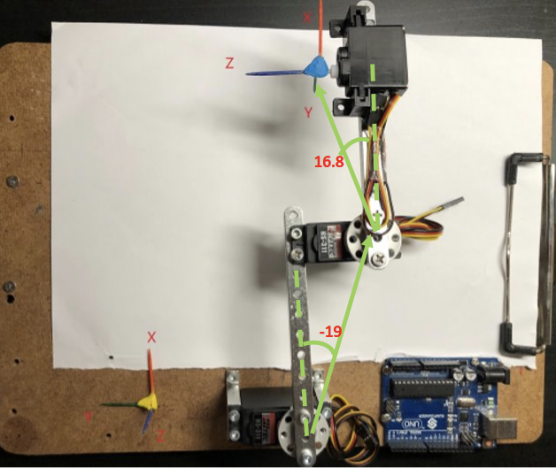

Fig. 5 offsets

And we also use Matlab APP GUI to adjust DH parameters and plot the robot to see how each parameter’s change will impact the robot arm structure.

a1=0.1 a1=0.2

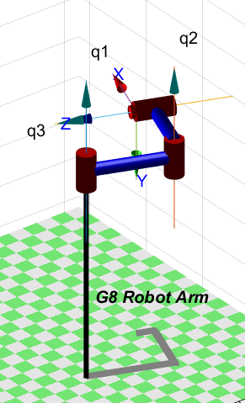 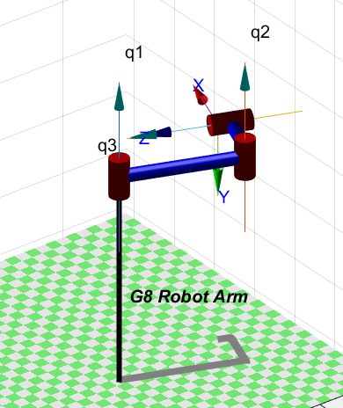

a1=0.2

a1=0.1

a2 = 0.073 a2 = 0.14

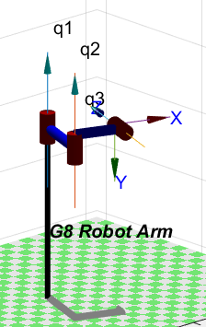 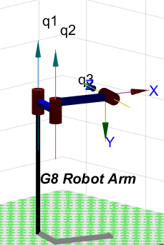

a2=0.14

a2=0.073

d2 = 0.02 d2 = 0.04

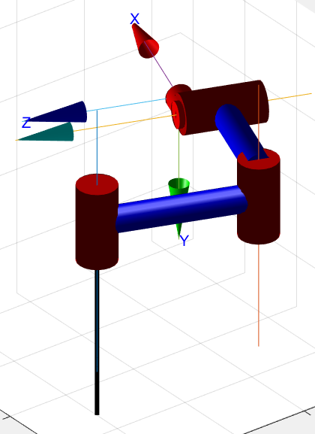 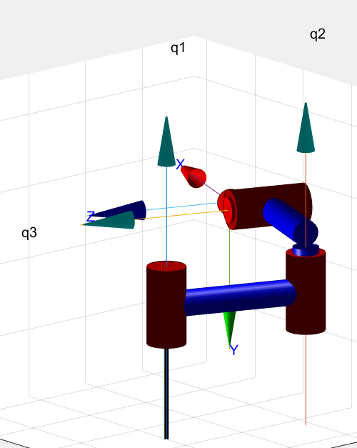

d2=0.02

d2=0.04

d3 = 0.2 d3 = 0.4

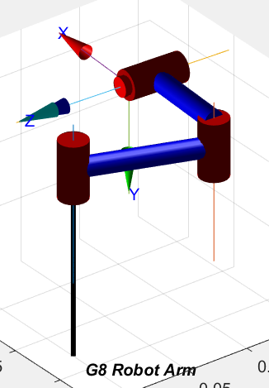 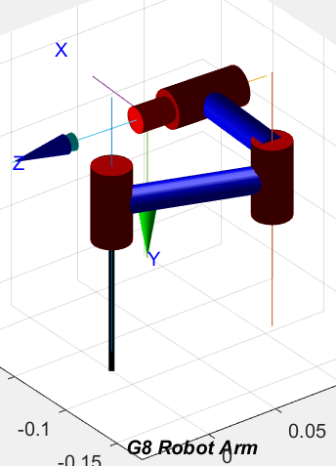

d3 = 0.2

d3 = 0.4

alpha1 = 0 alpha1 = 90 alpha21 = -90

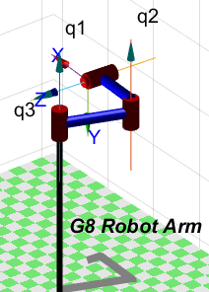 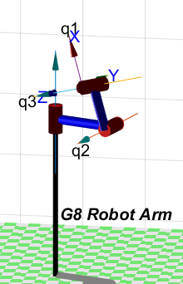 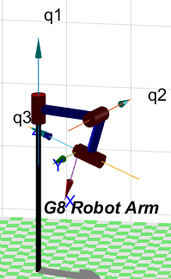

alpha2 = -90 alpha2 = 90 alpha2 = 0

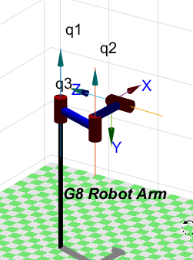 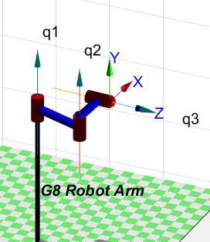 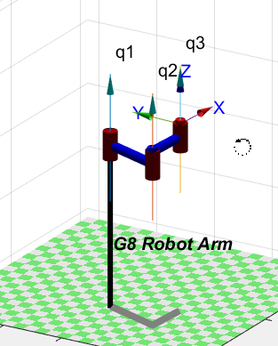

offset1 = -20º offset1 = 0º offset1 = 20º

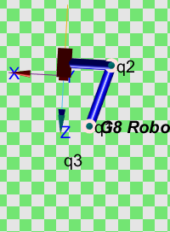 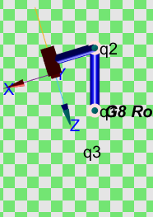 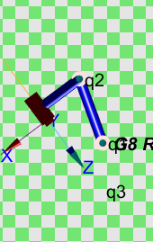

offset2 = 16.8º offset2 = 0º offset2 = -16.8º

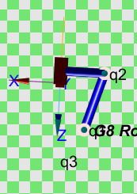 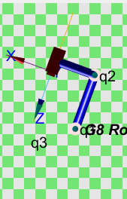 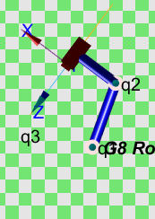

1. To create the robot from DH parameters, we use a CreateRobot function shown as Fig. 6. This is a callback function of “CreateRobot” button, which draws the DH parameters to each Link by using L(i) = Revolute (DH parameters), where “Revolute” means to create a link with a revolute joint. Then we create a robot variable app. G8Robot to store the robot information which is generated by SerialLink function, a function to create a robot from links we build eariler (combine those L(i) to a full matrix, and feed it to the SerialLink() as a augment). Note that the joint angle limit is also presented in “qlim” label.

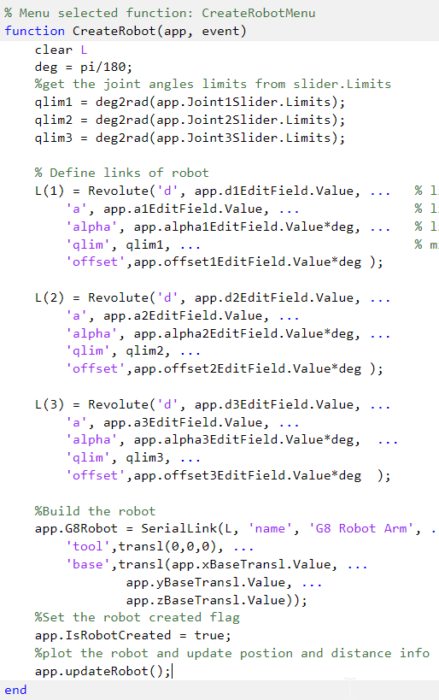

Fig. 6 Commands

1. The joint limits are declared in the “qlim” as an augment of Revolute(), meanwhile, in the latter design, we place a limit on the joint angle by setting limit values in the slider of the Matlab App designer.

In the step 5, we are using sliders to control the join angle and plot the robot in the GUI. Shown as Fig.7, the robot could be updated by each change in the sliders using a callback function that calls app.updateRobot() (a method in the class) to use app.G8Robot.plot function to plot the updated robot.

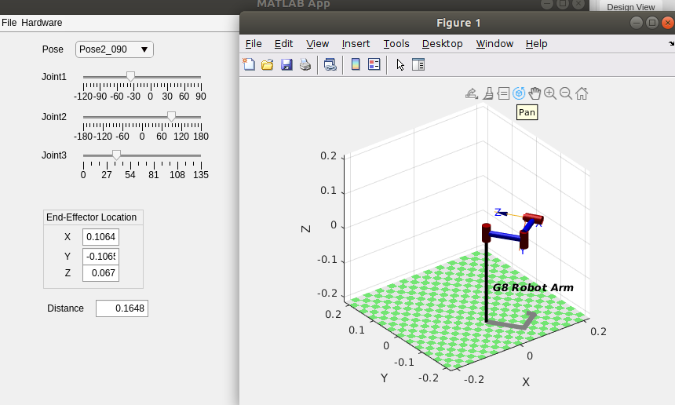

Fig. 7 Slider control

In the step 6, the codes used to implement keyboard control are shown in the Fig.8, we use UIFigureKeyRelease(app, event) function to get the key input in the GUI window where event.key can get exactly the key we input in the GUI. So, when detect arrow keys, the respective operations will be performed. In this case, we use “leftarrow” and “rightarrow” keys to control robot end-effector to move on the Y direction and use “uparrow” and “downarrow” to control robot end-effector to move on the X direction. For example, we get the “leftarrow” key as an input, the codes will update the end-effector transform matrix by changing the translation part with a motion along Y at 0.005, then get all joint angles stored in q2 by using inverse kinematic function ikine(), then update the slider value and call app.updateRobot() to plot the new robot configuration. As the ikine function may output unexpected result due to multiple solution. So we use the previous joint angles as q0 initial joint angles configuration. And we also added some checking condition for angles reach limits or ikine function has no solution, then a message box will give a warning about it.

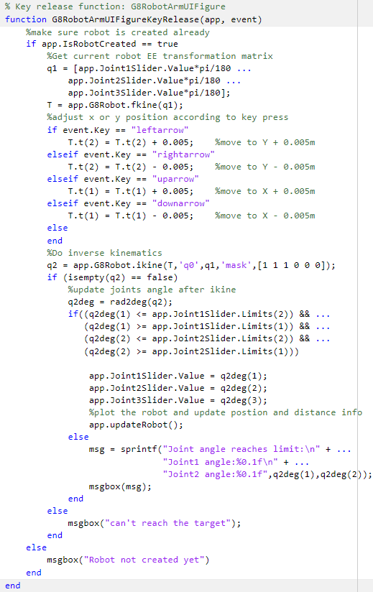

Fig.8 Keyboard Control

In the step 7, we determine 9 poses and measure the distance from end-effector to the new base frame (clipboard frame), also, we calculated respective distance by firstly using the fkine() function to get a transform matrix of end-effector and also get the translation part and then use the translation part to calculate the distance to the base frame, which is implemented in the class method app.updateRobot(). All the poses, measurements and calculations are listed in the Table. 2. Also, the poses and measurements of the distance are stored in the file DistanceData.txt.

|  |  |  |  |  |  |  |
| --- | --- | --- | --- | --- | --- | --- |
|  | Joint 1  (degree) | Joint 2  (degree) | Joint 3  (degree) | Measured Distance  (meters) | Calculated  Distance  (meters） | Error  (meters） |
| Pose_1 | 0 | 0 | 0 | 0.212 | 0.2047 | 0.0073 |
| Pose_2 | 0 | 90 | 0 | 0.115 | 0.1095 | 0.0055 |
| Pose_3 | 90 | -90 | 0 | 0.233 | 0.2273 | 0.0057 |
| Pose_4 | 90 | 0 | 0 | 0.118 | 0.1119 | 0.0061 |
| Pose_5 | 90 | 90 | 0 | 0.087 | 0.07868 | 0.00832 |
| Pose_6 | 90 | -90 | 0 | 0.136 | 0.1296 | 0.0064 |
| Pose_7 | -90 | 0 | 0 | 0.264 | 0.2576 | 0.0064 |
| Pose_8 | -90 | 90 | 0 | 0.175 | 0.1759 | 0.0009 |
| Pose_9 | -90 | -90 | 0 | 0.231 | 0.2292 | 0.0018 |
|  | | | | | Average | 0.00538 |

Table 2. Poses and distance

In step 8, we write an objective function shown as Fig.9. As an input of this function, dh is a matrix that combined all DH parameters, offsets and base frame translation. Then we use the DH paramters to create our robot and then load the poses and measurements from DistanceData.txt. Then we use each pose to calculate a transform matrix of end-effector by using fkine() function, and finally calculate the distance from end-effector to the clipboard frame by get the translation part in the transform matrix and apply distance function to get the final calculated distance. Then use the average absolute value of the difference between measurements and calculated distance to be the error.

In summary, the objective function is to calculate the distance error between measurements and calculations, and then the error could be optimized in the later fminsearch() function.

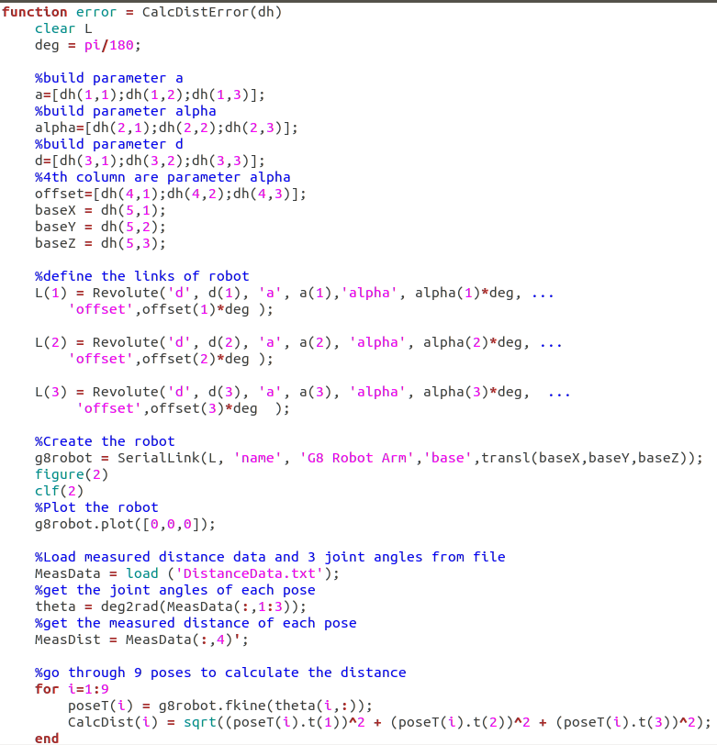

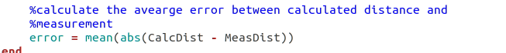

Fig.9 Objective Function

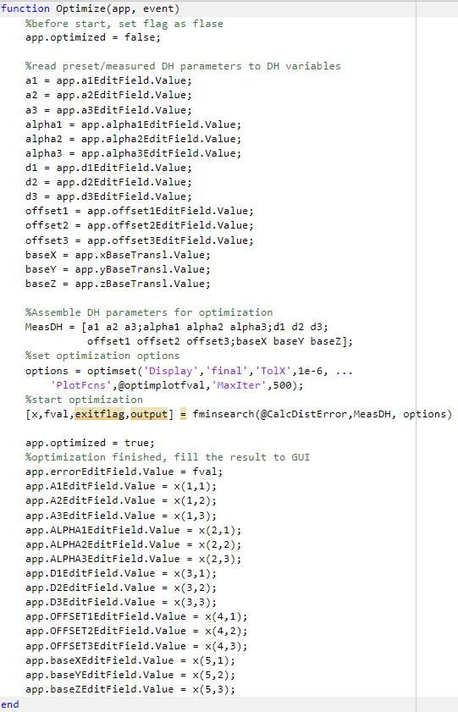

Fig. 10 Optimization

In the callback function of “Optimize” button, we perform Optimize () function which uses fminsearch() function as its core function. The input parameters of fminsearch() function are the objective function (CalcDistError()), a matrix of DH parameters (MeasDH), options. While the objective function represents what you want to optimize, DH parameters are what can affect objective function and can be tuned. And options are about some setting of plotting requirements, tolerated error range (1e-6), and the number of iterations (500 interations). The output contains improved parameters matrix “x” and final error value “fval”.

1. **Results**

In this section, we will explain our designed App, showcasing its functionality and show the results of optimization. This project has three main files:

* G8RobotArm.mlapp
* CalcDistError.m
* DistanceData.txt

The relationship among them is that .mlapp file is our designed App, so it could be regarded as the body of the project, .m file is used as the objective function in the fminsearch() function, while the .txt file contains 9 poses and corresponding distance measurements from end-effector to the new base frame, which is to be used in the CalcDistError() function.

The below shows our GUI window,

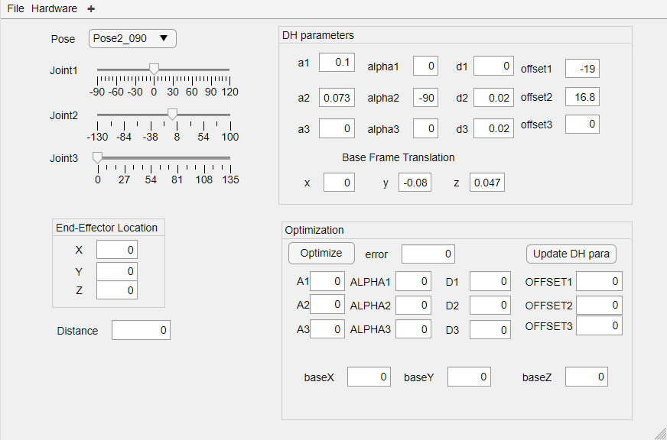

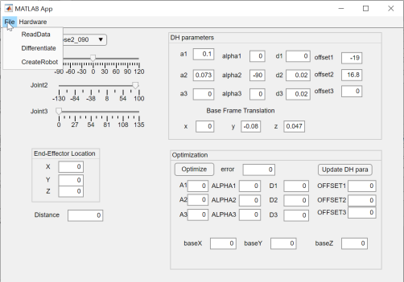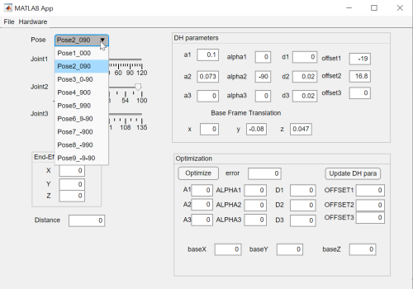

Fig. 11 GUI window.

And you can edit DH parameters, base frame translation parameters in it. Also, you can choose a pose and then press the “CreatRobot” button to create a robot. By tune the slider position, the robot can be re-plotted, which is showcased in Fig. 7. Then end-effector location and distance to the new base frame are also presented in the left side of the GUI window.

Next, we will showcase how optimization works in the GUI.

By pressing the “Optimize” button, the optimization of DH will be performed. Then the robot will be updated in the plot window, and the error will be improved in another window.

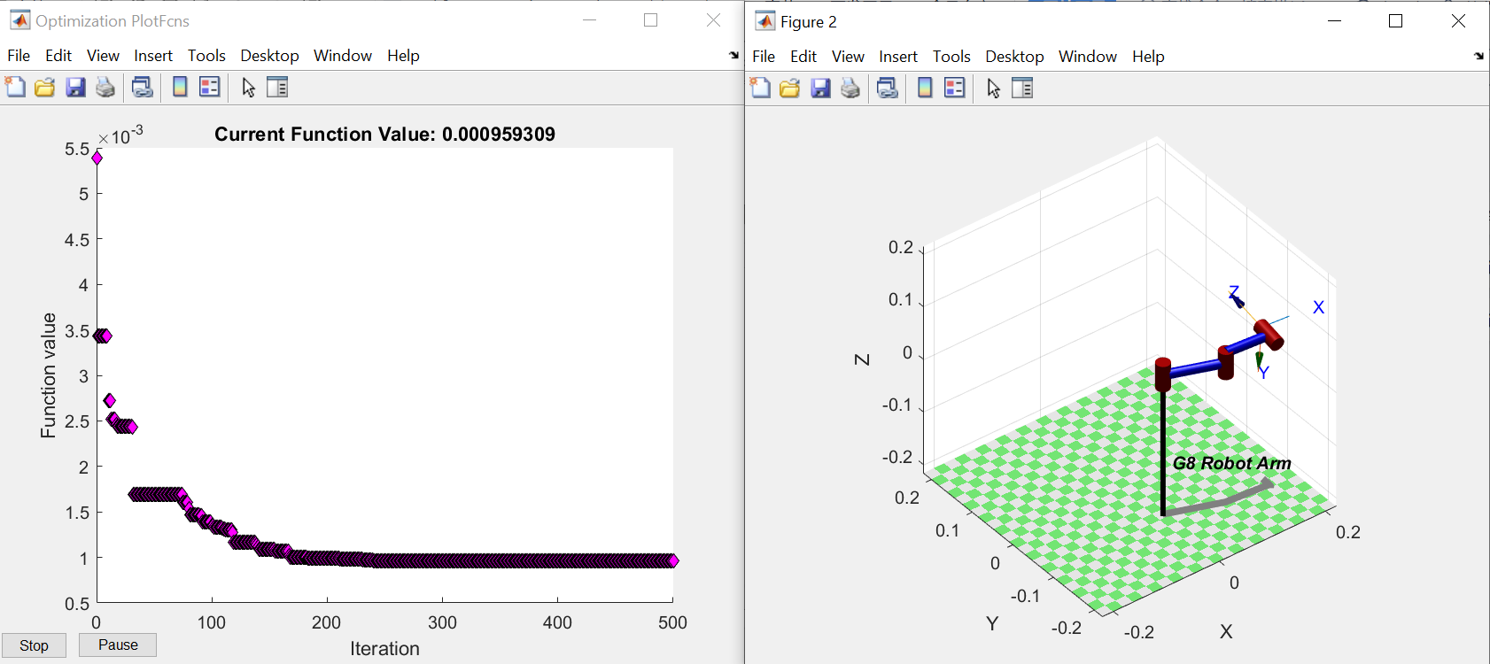

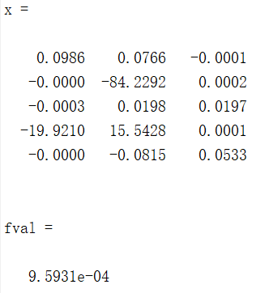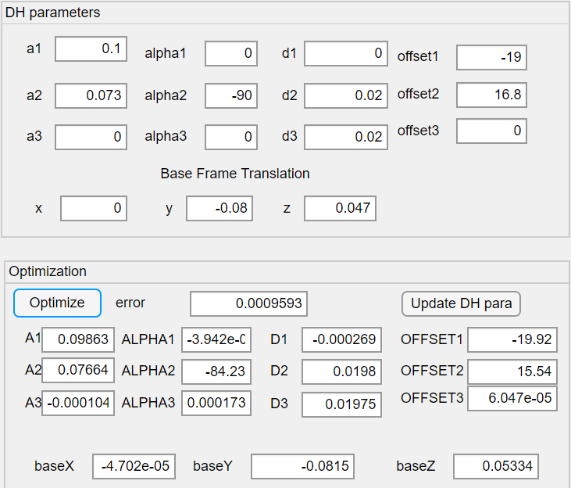

Fig. 12 Optimization window

After each optimization iteration, the DH parameters will be updated, and the robot will be re-plotted in the plot window. After 500 iterations, the error is reduced from 0.0054 to 0.00096, which is improved significantly.

Then we can fill optimized parameters to upper DH parameters and recalculate the distance, compare it with our measured distance, see below table, it is reduced a lot.

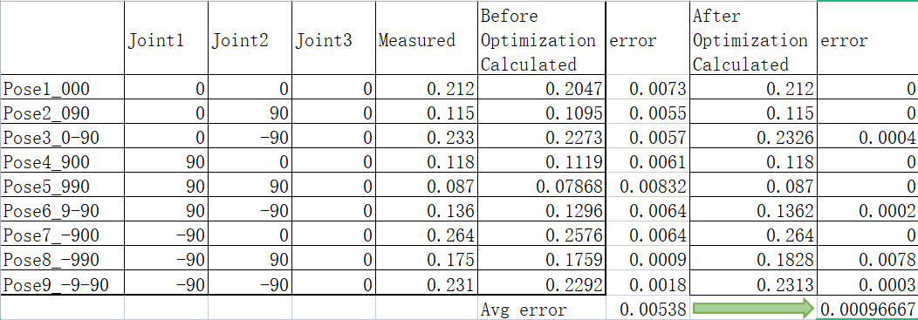

1. **Conclusion**

Before we build a real hardware robot arm, we can create a robot arm model to verify our hardware robot arm and tune our measured DH parameters to improve our robot arm performance.

1. **Discussion**

About the robot arm reachable area and the ikine function output solution need more study on it.

1. **Appendix**
2. Video Link

Robot arm setup: <https://www.youtube.com/watch?v=W543S_3lmbM>

Robot arm GUI: <https://www.youtube.com/watch?v=ctb90lQvoHY>

1. Code

Github: <https://github.com/linliawxm/RobotArm>

G8 Robot Arm app main functions:

properties (Access = private)

DataRead = false; % Initialize as false

Data = []; %buffer for reading data

DiffData = [];

arduino_hardware = [];

arduino_initialized = true;

G8Robot = [];

IsRobotCreated = false;

optimized = false;

% some useful poses

Pose = [0 0 0; %Pose1

0 90 0; %Pose2

0 -90 0; %Pose3

90 0 0; %Pose4

90 90 0; %Pose5

90 -90 0; %Pose6

-90 0 0; %Pose7

-90 90 0; %Pose8

-90 -90 0]; %Pose9

End

methods (Access = private)

function results = updateRobot(app)

if app.IsRobotCreated == true

%Re-plot robot for new pose

app.G8Robot.plot([app.Joint1Slider.Value*pi/180 ...

app.Joint2Slider.Value*pi/180 ...

app.Joint3Slider.Value*pi/180],"jvec");

%Recalculate the Transformation matrix after joint angle

%changed

T = app.G8Robot.fkine([app.Joint1Slider.Value*pi/180 ...

app.Joint2Slider.Value*pi/180 ...

app.Joint3Slider.Value*pi/180]);

%Update the EE position on GUI

app.XEditField.Value = T.t(1);

app.YEditField.Value = T.t(2);

app.ZEditField.Value = T.t(3);

%Calculate the distance of EE and update on GUI

app.DistanceEditField.Value = sqrt(T.t(1)^2 + T.t(2)^2 + T.t(3)^2);

else

msgbox("Robot not created yet")

end

end

End

% Code that executes after component creation

function startupFcn(app)

%Set initial joints angle according to pose selection

poseInx = str2num(app.PoseDropDown.Value);

app.Joint1Slider.Value = app.Pose(poseInx,1);

app.Joint2Slider.Value = app.Pose(poseInx,2);

app.Joint3Slider.Value = app.Pose(poseInx,3);

end

% Menu selected function: InitArduinoMenu

function Initialize(app, event)

try

app.arduino_hardware = arduino();

catch

msgbox('error on hardware initialize');

return;

end

app.arduino_initialized = true;

msgbox('Arduino initialized');

end

% Menu selected function: TestArduinoMenu

function TestArduino(app, event)

if(app.arduino_initialized)

app.arduino_hardware.writeDigitalPin("D13",1);

end

end

% Menu selected function: ReadDataMenu

function ReadData(app, event)

[fn pn] = uigetfile('*.txt', 'Where is the data?');

filename = [pn fn];

app.Data = textread(filename);

plot(app.UIAxes, app.Data(:,1),app.Data(:,2));

app.DataRead = true;

app.DataReadLamp.Color = [0.0 1.0 0.0];

app.InfoTextArea.Value = 'Data has been read.';

end

% Menu selected function: DifferentiateMenu

function Differentiate(app, event)

if(app.DataRead)

app.DiffData = app.Data;

app.DiffData(1:999,2) = diff(app.Data(:,2));

hold(app.UIAxes,'on');

plot(app.UIAxes, app.DiffData(:,1),app.DiffData(:,2),'g');

app.InfoTextArea.Value = 'Green is the differential';

else

app.InfoTextArea.Value = 'Read the data first';

end

end

% Menu selected function: CreateRobotMenu

function CreateRobot(app, event)

clear L

deg = pi/180;

%get the joint angles limits from slider.Limits

qlim1 = deg2rad(app.Joint1Slider.Limits);

qlim2 = deg2rad(app.Joint2Slider.Limits);

qlim3 = deg2rad(app.Joint3Slider.Limits);

% Define links of robot

L(1) = Revolute('d', app.d1EditField.Value, ... % link length (Dennavit-Hartenberg notation)

'a', app.a1EditField.Value, ... % link offset (Dennavit-Hartenberg notation)

'alpha', app.alpha1EditField.Value*deg, ... % link twist (Dennavit-Hartenberg notation)

'qlim', qlim1, ... % minimum and maximum joint angle

'offset',app.offset1EditField.Value*deg );

L(2) = Revolute('d', app.d2EditField.Value, ...

'a', app.a2EditField.Value, ...

'alpha', app.alpha2EditField.Value*deg, ...

'qlim', qlim2, ...

'offset',app.offset2EditField.Value*deg );

L(3) = Revolute('d', app.d3EditField.Value, ...

'a', app.a3EditField.Value, ...

'alpha', app.alpha3EditField.Value*deg, ...

'qlim', qlim3, ...

'offset',app.offset3EditField.Value*deg );

%Build the robot

app.G8Robot = SerialLink(L, 'name', 'G8 Robot Arm', ...

'tool',transl(0,0,0), ...

'base',transl(app.xBaseTransl.Value, ...

app.yBaseTransl.Value, ...

app.zBaseTransl.Value));

%Set the robot created flag

app.IsRobotCreated = true;

%plot the robot and update postion and distance info

app.updateRobot();

end

% Value changed function: a1EditField

function Update_a1(app, event)

if app.IsRobotCreated == true

%clear current figure before re-plot

clf;

%update robot a1 parameter

app.G8Robot.links(1).a = app.a1EditField.Value;

%plot the robot and update postion and distance info

app.updateRobot();

end

end

% Key release function: G8RobotArmUIFigure

function G8RobotArmUIFigureKeyRelease(app, event)

%make sure robot is created already

if app.IsRobotCreated == true

%Get current robot EE transformation matrix

q1 = [app.Joint1Slider.Value*pi/180 ...

app.Joint2Slider.Value*pi/180 ...

app.Joint3Slider.Value*pi/180];

T = app.G8Robot.fkine(q1);

%adjust x or y position according to key press

if event.Key == "leftarrow"

T.t(2) = T.t(2) + 0.005; %move to Y + 0.005m

elseif event.Key == "rightarrow"

T.t(2) = T.t(2) - 0.005; %move to Y - 0.005m

elseif event.Key == "uparrow"

T.t(1) = T.t(1) + 0.005; %move to X + 0.005m

elseif event.Key == "downarrow"

T.t(1) = T.t(1) - 0.005; %move to X - 0.005m

else

end

%Do inverse kinematics

q2 = app.G8Robot.ikine(T,'q0',q1,'mask',[1 1 1 0 0 0]);

if (isempty(q2) == false)

%update joints angle after ikine

q2deg = rad2deg(q2);

if((q2deg(1) <= app.Joint1Slider.Limits(2)) && ...

(q2deg(1) >= app.Joint1Slider.Limits(1)) && ...

(q2deg(2) <= app.Joint2Slider.Limits(2)) && ...

(q2deg(2) >= app.Joint2Slider.Limits(1)))

app.Joint1Slider.Value = q2deg(1);

app.Joint2Slider.Value = q2deg(2);

app.Joint3Slider.Value = q2deg(3);

%plot the robot and update postion and distance info

app.updateRobot();

else

msg = sprintf("Joint angle reaches limit:\n" + ...

"Joint1 angle:%0.1f\n" + ...

"Joint2 angle:%0.1f",q2deg(1),q2deg(2));

msgbox(msg);

end

else

msgbox("can't reach the target");

end

else

msgbox("Robot not created yet")

end

end

% Value changed function: PoseDropDown

function ChangePose(app, event)

%make sure robot is created already

if app.IsRobotCreated == true

%update joints angle according to pose selection

poseinx = str2num(app.PoseDropDown.Value);

app.Joint1Slider.Value = app.Pose(poseinx,1);

app.Joint2Slider.Value = app.Pose(poseinx,2);

app.Joint3Slider.Value = app.Pose(poseinx,3);

%plot the robot and update postion and distance info

app.updateRobot();

else

msgbox("Robot not created yet")

end

end

% Value changed function: Joint1Slider

function Joint1SliderValueChanged(app, event)

%plot the robot and update postion and distance info

app.updateRobot();

end

% Value changed function: Joint2Slider

function Joint2SliderValueChanged(app, event)

%plot the robot and update postion and distance info

app.updateRobot();

end

% Value changed function: Joint3Slider

function Joint3SliderValueChanged(app, event)

%plot the robot and update postion and distance info

app.updateRobot();

end

% Button pushed function: OptimizeButton

function Optimize(app, event)

%before start, set flag as flase

app.optimized = false;

%read preset/measured DH parameters to DH variables

a1 = app.a1EditField.Value;

a2 = app.a2EditField.Value;

a3 = app.a3EditField.Value;

alpha1 = app.alpha1EditField.Value;

alpha2 = app.alpha2EditField.Value;

alpha3 = app.alpha3EditField.Value;

d1 = app.d1EditField.Value;

d2 = app.d2EditField.Value;

d3 = app.d3EditField.Value;

offset1 = app.offset1EditField.Value;

offset2 = app.offset2EditField.Value;

offset3 = app.offset3EditField.Value;

baseX = app.xBaseTransl.Value;

baseY = app.yBaseTransl.Value;

baseZ = app.zBaseTransl.Value;

%Assemble DH parameters for optimization

MeasDH = [a1 a2 a3;alpha1 alpha2 alpha3;d1 d2 d3;

offset1 offset2 offset3;baseX baseY baseZ];

%set optimization options

options = optimset('Display','final','TolX',1e-6, ...

'PlotFcns',@optimplotfval,'MaxIter',500);

%start optimization

[x,fval,exitflag,output] = fminsearch(@CalcDistError,MeasDH, options)

app.optimized = true;

%optimization finished, fill the result to GUI

app.errorEditField.Value = fval;

app.A1EditField.Value = x(1,1);

app.A2EditField.Value = x(1,2);

app.A3EditField.Value = x(1,3);

app.ALPHA1EditField.Value = x(2,1);

app.ALPHA2EditField.Value = x(2,2);

app.ALPHA3EditField.Value = x(2,3);

app.D1EditField.Value = x(3,1);

app.D2EditField.Value = x(3,2);

app.D3EditField.Value = x(3,3);

app.OFFSET1EditField.Value = x(4,1);

app.OFFSET2EditField.Value = x(4,2);

app.OFFSET3EditField.Value = x(4,3);

app.baseXEditField.Value = x(5,1);

app.baseYEditField.Value = x(5,2);

app.baseZEditField.Value = x(5,3);

end

% Value changed function: a2EditField

function update_a2(app, event)

if app.IsRobotCreated == true

%clear current figure before re-plot

clf;

%update robot a1 parameter

app.G8Robot.links(2).a = app.a2EditField.Value;

%plot the robot and update postion and distance info

app.updateRobot();

end

end

% Value changed function: d1EditField

function update_d1(app, event)

if app.IsRobotCreated == true

%clear current figure before re-plot

clf;

%update robot a1 parameter

app.G8Robot.links(1).d = app.d1EditField.Value;

%plot the robot and update postion and distance info

app.updateRobot();

end

end

% Value changed function: d2EditField

function update_d2(app, event)

if app.IsRobotCreated == true

%clear current figure before re-plot

clf;

%update robot a1 parameter

app.G8Robot.links(2).d = app.d2EditField.Value;

%plot the robot and update postion and distance info

app.updateRobot();

end

end

% Value changed function: d3EditField

function update_d3(app, event)

if app.IsRobotCreated == true

%clear current figure before re-plot

clf;

%update robot a1 parameter

app.G8Robot.links(3).d = app.d3EditField.Value;

%plot the robot and update postion and distance info

app.updateRobot();

end

end

% Value changed function: alpha2EditField

function update_alpha2(app, event)

if app.IsRobotCreated == true

%clear current figure before re-plot

clf;

%update robot a1 parameter

app.G8Robot.links(2).alpha = deg2rad(app.alpha2EditField.Value);

%plot the robot and update postion and distance info

app.updateRobot();

end

end

% Value changed function: offset1EditField

function update_offset1(app, event)

if app.IsRobotCreated == true

%clear current figure before re-plot

%clf;

%update robot a1 parameter

app.G8Robot.offset(1) = app.offset1EditField.Value*pi/180;

%plot the robot and update postion and distance info

app.updateRobot();

end

end

% Value changed function: offset2EditField

function update_offset2(app, event)

if app.IsRobotCreated == true

%clear current figure before re-plot

%clf;

%update robot a1 parameter

app.G8Robot.offset(2) = app.offset2EditField.Value*pi/180;

%plot the robot and update postion and distance info

app.updateRobot();

end

end

% Button pushed function: UpdateDHparaButton

function UpdateDHPara(app, event)

if app.optimized

app.a1EditField.Value = app.A1EditField.Value;

app.a2EditField.Value = app.A2EditField.Value;

app.a3EditField.Value = app.A3EditField.Value;

app.alpha1EditField.Value = app.ALPHA1EditField.Value;

app.alpha2EditField.Value = app.ALPHA2EditField.Value;

app.alpha3EditField.Value = app.ALPHA3EditField.Value;

app.d1EditField.Value = app.D1EditField.Value;

app.d2EditField.Value = app.D2EditField.Value;

app.d3EditField.Value = app.D3EditField.Value;

app.offset1EditField.Value = app.OFFSET1EditField.Value;

app.offset2EditField.Value = app.OFFSET2EditField.Value;

app.offset3EditField.Value = app.OFFSET3EditField.Value;

app.xBaseTransl.Value = app.baseXEditField.Value;

app.yBaseTransl.Value = app.baseYEditField.Value;

app.zBaseTransl.Value = app.baseZEditField.Value;

end

end

% Value changed function: alpha1EditField

function update_alpha1(app, event)

if app.IsRobotCreated == true

%clear current figure before re-plot

%clf;

%update robot a1 parameter

app.G8Robot.links(1).alpha = deg2rad(app.alpha1EditField.Value);

%plot the robot and update postion and distance info

app.updateRobot();

end

end

Objective function:

%Objective function to calculate the end effector distance from the

%clipboard coordinate system origin

%Input parameter:

% DH parameters of 3 links robot

% dh = [a1 a2 a3;

% alpha1 alpha2 alpha3;

% d1 d2 d3;

% offset1 offset2 offset3;

% baseX baseY baseZ]

function error = CalcDistError(dh)

clear L

deg = pi/180;

%build parameter a

a=[dh(1,1);dh(1,2);dh(1,3)];

%build parameter alpha

alpha=[dh(2,1);dh(2,2);dh(2,3)];

%build parameter d

d=[dh(3,1);dh(3,2);dh(3,3)];

%4th column are parameter alpha

offset=[dh(4,1);dh(4,2);dh(4,3)];

baseX = dh(5,1);

baseY = dh(5,2);

baseZ = dh(5,3);

%define the links of robot

L(1) = Revolute('d', d(1), 'a', a(1),'alpha', alpha(1)*deg, ...

'offset',offset(1)*deg );

L(2) = Revolute('d', d(2), 'a', a(2), 'alpha', alpha(2)*deg, ...

'offset',offset(2)*deg );

L(3) = Revolute('d', d(3), 'a', a(3), 'alpha', alpha(3)*deg, ...

'offset',offset(3)*deg );

%Create the robot

g8robot = SerialLink(L, 'name', 'G8 Robot Arm','base',transl(baseX,baseY,baseZ));

%figure(2)

%clf(2)

%Plot the robot

%g8robot.plot([0,0,0]);

%Load measured distance data and 3 joint angles from file

MeasData = load ('DistanceData.txt');

%get the joint angles of each pose

theta = deg2rad(MeasData(:,1:3));

%get the measured distance of each pose

MeasDist = MeasData(:,4)';

%go through 9 poses to calculate the distance

for i=1:9

poseT(i) = g8robot.fkine(theta(i,:));

%T.t = [x;y;z]

CalcDist(i) = sqrt((poseT(i).t(1))^2 + (poseT(i).t(2))^2 + (poseT(i).t(3))^2);

end

%calculate the avearge error between calculated distance and

%measurement

error = mean(abs(CalcDist - MeasDist))

end